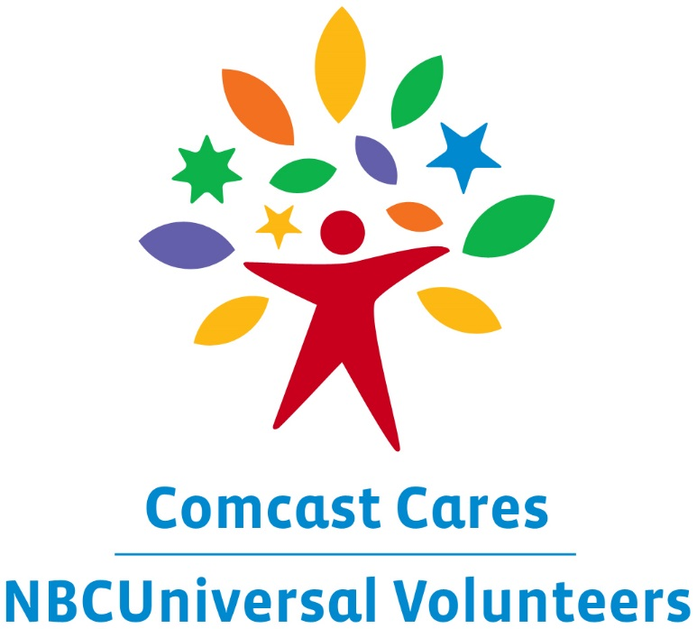

COMCAST CARES DAY 2016
Volunteer Day of Service

Community Service Project Solicitation

Please Submit to:
Inside Comcast
E-mail: Inside_Comcast@cable.comcast.com

Deadline: February 1, 2016
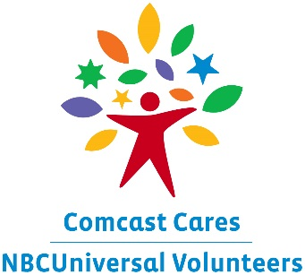

COMCAST CARES DAY 2016
Volunteer Day of Service
Help Comcast Give Back to the Community
Saturday, April 30, 2016

Comcast Cares Day is Comcast’s annual company-wide day of service in which tens of thousands of Comcast employees, along with their families and friends, volunteer in their local communities. We are committed to improving the quality of life in local communities where our customers and employees live and work. Comcast works with existing local nonprofit organizations to positively impact each community we serve while using our resources to bring visibility to important local issues. To date, more than 400,000 volunteers have contributed over 2.2 million hours of service at nearly 3,600 project sites in local communities.

Who is eligible?
We are seeking proposals from community-based organizations, such as public nonprofits, school districts and other organizations that provide public services within the Comcast service area.

What types of projects are accepted?
Our employees are a multi-talented group of volunteers looking to help out the communities where they live and work. They enjoy projects that involve computer literacy training, resume writing, building, painting, cleaning, organizing, landscaping, technology training, etc. The project should be able to be completed in approximately 4-5 hours.

Keep in mind that it must be a community service project, either by directly providing a service to the community or by providing a service to a community-based organization that provides community services. The project site must be located within the Comcast service area.

Project date range: Wednesday, April 20 – Monday, May 2.

We will be evaluating all proposals in a variety of areas, such as:

- The extent to which a sizable group of people can make a concrete impact in a single day

- Opportunities for collaborative work and team-building

- The effect that the completed project will have on the organization, those served by it, and the community at large

Organizational Information

Org. Legal Name :

Executive Director Name:

Executive Director Address:

Project Contact Person:

Address:

Phone:

Fax:

E-mail :

Website:

Facebook Page:

Tax ID# (EIN)

Please provide a brief description of your organization, its mission, programs and services. (200 words or less)

Please provide a description of the overall project, including how this project will serve the community or assist your organization in serving the community.

Please list the site location/addresses where your project will occur if other than your organization address.

Please provide a description of the type of work activities that would be required in undertaking this project (i.e. painting, general clean-up, landscaping, etc.)

Please list the minimum and maximum number of volunteers needed to complete your project.
Minimum Maximum
We will have other volunteers as well, but would love to have between 20-60 from Comcast.
Will this project allow for participation by children, adults and seniors?
Yes No
Can this volunteer project be accomplished in one day?
Yes No
Will your organization be able to supply volunteers? If so, how many volunteers can you provide?
Yes No # of volunteers you can provide
Please list the tools, materials and other resources required to complete your project. (i.e. paint, rakes, brooms, etc.)

Enter the total number of people who are served by your organization? ________
Can this organization accommodate parking for the maximum number of volunteers needed?
Yes No

What is the number of parking spaces available?

Is there an additional space available where everyone can gather before and after the event? If so, please list the location address.
Yes No
Address:

Selection Process
Once the Comcast Cares Day selections have been made we will notify the partnering organizations shortly thereafter. Selected community partners will be asked to agree to certain terms and conditions. Due to the number of worthy nonprofit organizations, we will not be able to provide community service to all requests submitted. Please feel free to include any additional information and materials about your organization that you feel may be of assistance.

Thank you for your interest. We look forward to hearing from you.

