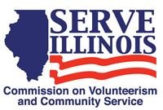
www.Serve.Illinois.gov
Strategic Plan Committee Meeting Agenda
Meeting date:
Monday, April 25, 2022
11:00am-12:00pm CST

Locations
Virtual Meeting Via WebEx

Virtual Meeting Credentials:
To receive the link to this meeting, please contact us at dhs.serveillinois@illinois.gov to receive the link.
Agenda
- Call to Order - Chair
- Roll Call- Commissioners, please type your name in the chat - Chair
- Approval of Minutes – Chair
- Executive Director Update
- Review of strategic planning timeline
- Draft Strategic Plan
    - Development of over-arching goals for commission
- Next Steps
    - Next Meeting date and agenda
- Adjournment

