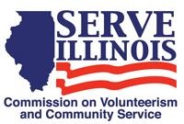
www.Serve.Illinois.gov
Public Policy Committee Meeting Agenda
Meeting date:
Wednesday, January 19, 2022
11:00am-12:00pm CST

Locations
Virtual Meeting Via WebEx

Virtual Meeting Credentials:
To receive the link to this meeting, please contact us at dhs.serveillinois@illinois.gov to receive the link.
T Agenda
- Call to Order - Chair
- Roll Call- Commissioners, please type your name in the chat - Chair
- Approval of Minutes - Chair
- Education Award Tax Relief
- Removing bi-partisan requirement for the board
- Next Steps
    - Public Policy Committee role with strategic planning process check in
    - Next Meeting date and agenda
- Adjournment

