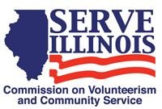
www.Serve.Illinois.gov
Public Relations Committee Meeting Agenda
Meeting date:
Wednesday, November 3rd, 2021
4:00 PM – 5:00 PM

Locations
Virtual Meeting Via Zoom

Virtual Meeting Credentials:
Provided in Meeting Invitation or contact Claire Sterling to get link at claire.starling@illinois.gov

Agenda
- Call to Order- Catherine Leonis
- Roll Call- Commissioners, please type your name in the chat.
- Approval of Minutes- Catherine Leonis
- Branding Discussion- PGM Pamela Taylor
- Serve Outreach Proposal
- Discuss the goals of our Branding Strategy
- Next Steps
- Committee Member Inquiry
- Serve Illinois Newsletter- Cassie McNeill
- Serve Illinois Event Updates- Cassie McNeill
- Discussion and Input
- Next Steps
- Adjourned

