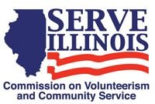
www.Serve.Illinois.gov
Public Relations Committee Meeting Agenda
Wednesday, January 19, 2022
4:00 PM – 5:00 PM
Virtual Meeting Credentials:
Provided in Meeting Invitation or contact Jacob Jenkins to get link at jacob.jenkins2@illinois.gov

Agenda
- Call to Order- Catherine Leonis
- Roll Call- Commissioners, please type your name in the chat.
- Approval of Minutes- Catherine Leonis
- DHS PR and Communication Policy and Procedures- Jacob Jenkins
- Branding Strategy Review- pages 11-14 of packet
- Discuss the goals of our Branding Strategy
- Marketing Strategy
- Next Steps
- Serve Illinois Newsletter- Jacob Jenkins
- Serve Illinois Event Updates- Jacob Jenkins
- Next Meeting
- Adjourned

