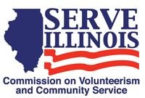
www.Serve.Illinois.gov
AmeriCorps Committee Meeting Agenda
Meeting date:
Tuesday, February 15, 2022
4:00pm-5:00pm

Locations
Virtual Meeting Via WebEx

Virtual Meeting Credentials:
Because this meeting will include information about funding decisions and current funding it is a closed meeting
Agenda
- Call to Order - Chair
- Roll Call- Commissioners, please type your name in the chat - Chair
- Approval of Minutes - Chair
- FY2022 Grantee Update (grant agreements, foundation relations) – Staff
- FY203 NOFO and funding decisions – staff
    - Planning grants
    - Continuation grants (year 3 of 3)
- State Service Plan (the AmeriCorps National Service Plan) Discussion
- AmeriCorps Committee role with strategic planning process
- Next Meeting Date and Agenda
- Adjournment

