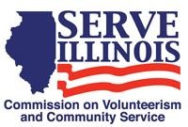
www.Serve.Illinois.gov
AmeriCorps Committee Meeting Agenda
Meeting date:
Tuesday, January 18, 2022
4:00pm-5:00pm

Locations
Virtual Meeting Via WebEx

Virtual Meeting Credentials:
Because this meeting will include information about funding decisions and current funding it is a closed meeting
Agenda
- Call to Order - Chair
- Roll Call- Commissioners, please type your name in the chat - Chair
- Approval of Minutes - Chair
- FY2022 Grantee Update (grant agreements, foundation relations) – Staff
- FY203 NOFO and funding decisions – Staff
- State Service Plan (the AmeriCorps National Service Plan)
- Next Steps
    - AmeriCorps Committee role with strategic planning process
    - Next Meeting Date and Agenda
- Adjournment

